ST. XAVIER’S COLLEGE

(Affiliated to Tribhuvan University)

Maitighar, Kathmandu



Database Management System

Lab Assignment #5

Submitted by:

Arun Sanjel  
013BSCCSIT010

Submitted to:

|  |  |
| --- | --- |
| Er. Sanjay Kumar Yadav  Lecturer  St. Xavier’s College |  |

Date of Submission: August 27, 2015

1. What do you mean by Entity- Relationship Diagram? Explain

ER-Diagram is a visual representation of data that describes how data is related to each other.The ER model defines the conceptual view of a database. It works around real-world entities and the associations among them. The Entity Relationship diagram show all the entity of database and relationship among the entities in pictorial form.ER diagram shows the basic schema of the database and helps in getting the conceptual idea of the database.

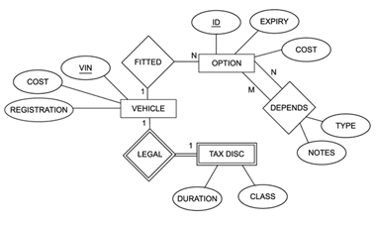

Figure ER diagram

1. Define entity and give an example.

Any real world object that has unique properties and can show its own identity with those properties is called an entity. The unique properties of the entity are called attributes. For example, in a school database, students, teachers, classes, and courses offered can be considered as entities. All these entities have some attributes or properties that give them their identity.

1. Explain the different between an entity class and an entity instance.
2. Define attribute and its types.

Attribute is the unique properties of an entity which makes the entity unique. Entities are represented by means of their properties, called attributes. All attributes have values. For example, a student entity may have name, class, roll, and age as attributes.

Types of attributes:

**Simple attribute**   
Simple attributes are atomic values, which cannot be divided further. For example, a student's phone number is an atomic value of 10 digits.

**Composite attribute**

Composite attributes are made of more than one simple attribute. For example, a student's complete name may have first_name and last_name.

**Derived attribute**

Derived attributes are the attributes that do not exist in the physical database, but their values are derived from other attributes present in the database. For example, average_salary in a department should not be saved directly in the database, instead it can be derived. For another example, age can be derived from data_of_birth.

**Single-value attribute**

Single-value attributes contain single value. For example − Social_Security_Number.

**Multi-value attribute**

Multi-value attributes may contain more than one value. For example, a person can have more than one phone number, email _address, etc

1. What is derived attributes?

Derived attributes are the attributes that do not exist in the physical database, but their values are derived from other attributes present in the database

Example:

Let ‘age’ be an attribute which is calculated from DOB. Now, **age = today date – DOB.** Here age is derived attribute.

Let ‘due_amount’ be an attribute which is calculated using two other attribute ‘total_amount’ and ‘paid_amount’ i.e**. due_amount = total_amount – paid_amount.**

1. Define relationship and give an example.

A relationship indicated how one or more entity classes interact with one and another. It is connection among different entity classes. Each entity plays a role in a relationship. Degree of the relationship: number of entities in a relationship. Understanding the relationship is important because it will affect how the database is constructed and used.

For example, in a bank database a ‘ CUSTOMER’ table stores customer data with a primary key column named CUSTOMER_ID; it also stores customer data in an ‘ACCOUNTS’ table, which holds information about various bank accounts and associated customers. To link these two tables and determine customer and bank account information, a corresponding CUSTOMER_ID column must be inserted in the ACCOUNTS table, referencing existing customer IDs from the CUSTOMER table. In this case, the ACCOUNTS table’s CUSTOMER_ID column is a foreign key that references a column with the same name in the CUSTOMER table. This is an example of a relationship between the two tables

1. Explain the difference between a relationship class and a relationship instance.
2. Define degree of relationship.

The number of participating entities in a relationship defines the degree of the relationship.

Here ,the degree of relationship is defined by the number of entity used in a relationship.

Binary = degree 2 i.e. 2 entities are used

Ternary = degree 3 i.e. 3 entities are used

n-ary = degree i.e. n entities are used

1. List and give an example of the three types of binary relationships. Draw an E-R diagram for each.

A binary relationship is when two entities participate and is the most common relationship degree.

Three types of binary relationship are:

**1:1 binary relationship:-** Two entities in a database have one to one relationship with one each attribute linking them is said to be 1:1 binary relationship.

**1:N binary relationship:-** Two entities in a database have one to many relationship each other is said to be 1:N binary relationship.

**M:N binary relationship:-** Two entities in a database have many to many relationship each other is said to be M:N binary relationship.

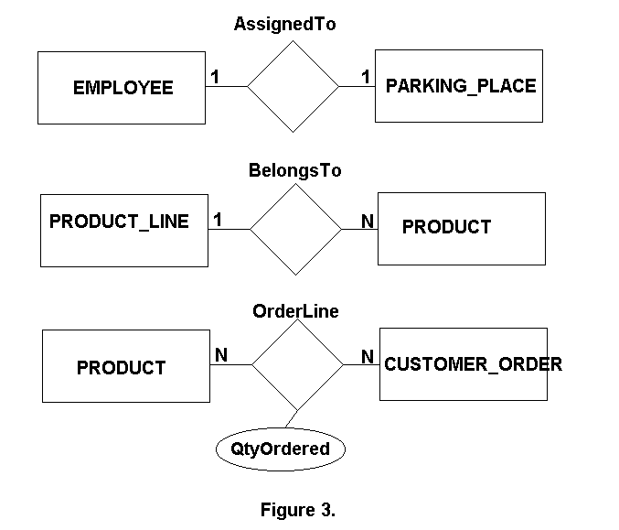

2. Define the terms maximum cardinality and minimum cardinality.

Cardinality defines the number of entities in one entity set, which can be associated with the number of entities of other set via relationship set.

Maximum cardinality is the maximum number of instances of an entity that can participate in an instance of a relationship. Minimum cardinality is the least number of instances of an entity that can participate in an instance of a relationship.

1. **Explain the distinctions among the terms primary key, candidate key and super key.**

**Super Key**

A Super key is any combination of fields within a table that uniquely identifies each record within that table. A super key is a combination of columns that uniquely identifies any row within a relational database management system (RDBMS) table. A candidate key is a closely related concept where the super key is reduced to the minimum number of columns required to uniquely identify each row.

**Candidate Key**

A candidate is a subset of a super key. A candidate key is a single field or the least combination of fields that uniquely identifies each record in the table. The least combination of fields distinguishes a candidate key from a super key. Every table must have at least one candidate key but at the same time can have several.

**Primary Key**

Key used by developer in the table is known as primary key. A primary key is a candidate key that is most appropriate to be the main reference key for the table. As its name suggests, it is the primary key of reference for the table and is used throughout the database to help establish relationships with other tables. As with any candidate key the primary key must contain unique values, must never be null and uniquely identify each record in the table.

1. What are the main building modules of the entity relationship model? Discuss each one.

The Entity-Relationship model is a top-down approach to design database that is based on uniquely identifiable object. If begins by identifying things that are uniquely distinguishable called entities and relationships among these entities.

The main building modules of the Entity-Relationship model are:

a. Entities

b. Relationships

c. Attributes

**Entities**

An Entity is a basic object of ER-model which is an object in real world that can be distinguishable and can exists independently.

**Relationships**

Relationship defines the association among two entities. Suppose, consider student and a class are the two entities. These entities are associated as “student studies in class”. Hence studies is a relationship between the two entities, student and class.

**Attributes**

The properties of the entities are called attributes.

For example if we consider a mobile phone as an entity then each mobile well have its own color, design, model company. All these are the attributes of the mobile entity.

1. What is composite attributes, when it is used?

Composite attributes are made of more than one simple attribute..Composite attribute are used when a single simple attribute cannot define the entire attribute.

For example: A attribute ‘name’ cannot stored the long name of the user so it is sub divided into three different attribute i.e. ‘fname’ , ‘mname’, ‘lname’to stored first name , middle name and last name respectively.

1. Explain the difference between single-value attributes and simple attributes.
2. Discuss the difference between a composite key and a composite attribute. How would

each indicated in an E-R diagram?

1. What two courses of action are available to a designer when a multi valued attribute is

encountered ?

1. Explain the various terms of an E-R model and how are they represented in an E-R

model?

1. Explain the concept of dependent entities? Give example.
2. What is the difference total and partial participation? Explain.
3. What do you mean by mapping cardinalities? Explain various types of cardinalities.
4. What is the difference between single-value and multi valued attributes? Explain
5. Explain the concept of participation constraints.
6. Difference the binary relationship with ternary relationship with example.
7. Explain the difference between weak and strong entity set.
8. Define the components of extended E-R features.
9. Define the concept of aggregation. Give two examples of where this concept is useful.
10. Explain the distinction between disjoint and overlapping constraints.
11. Explain the distinction between total and partial constraints.
12. Write short notes on:
    1. Specialization
    2. Generalization
    3. Aggregation